SANSKAAR PATNI
180905134 CSE C-23
OS LAB 4

1. inode
#include <stdio.h>
#include <stdlib.h>
#include <unistd.h>
#include <sys/types.h>
#include <sys/stat.h>

int main(int argc, char **argv)
{
struct stat sb;
if (argc == 1)
{
printf("No file name specified\n");
exit(0);
}
else if (argc == 2)
{
int status = stat(argv[1], &sb);
if (status == 0)
{
printf("Inode of the file is %ld\n", sb.st_ino);
exit(0);
}
else
{
printf("%m\n");
exit(1);
}
}
else
{
printf("Too many arguments specified\n");
exit(1);
}
}
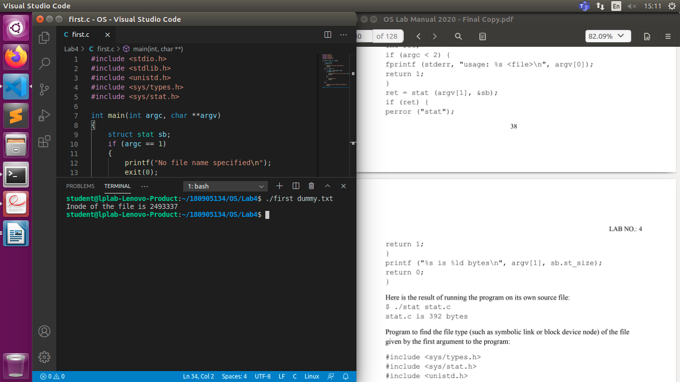
2. stat structure
#include <time.h>
#include <stdio.h>
#include <stdlib.h>
#include <sys/stat.h>
#include <sys/types.h>

int main(int argc, char *argv[])
{
struct stat sb;

if (argc != 2)
fprintf(stderr, "Usage: fstat FILE...\n"), exit(EXIT_FAILURE);

if ((stat(argv[1], &sb)) == -1)
{
perror("fstat");
return 1;
}

printf("filename: %s\n", argv[1]);
printf(" device: %lld\n", sb.st_dev);
printf(" inode: %ld\n", sb.st_ino);
printf(" protection: %o\n", sb.st_mode);
switch (sb.st_mode & S_IFMT)
{
case S_IFBLK:
printf("Block device node\n");
break;
case S_IFCHR:
printf("Character device node\n");
break;
case S_IFDIR:
printf("Directory\n");
break;
case S_IFIFO:
printf("FIFO\n");
break;
case S_IFLNK:
printf("SYMBOLIC Link\n");
break;
case S_IFREG:
printf("Regular File\n");
break;
default:
printf("Unkown\n");
break;
}
printf(" number of hard links: %d\n", sb.st_nlink);
printf(" user ID of owner: %d\n", sb.st_uid);
printf(" group ID of owner: %d\n", sb.st_gid);
printf(" device type (if inode device): %lld\n", sb.st_rdev);
printf(" total size, in bytes: %ld\n", sb.st_size);
printf(" blocksize for filesystem I/O: %ld\n", sb.st_blksize);
printf(" number of blocks allocated: %ld\n", sb.st_blocks);
printf(" time of last access: %ld : %s", sb.st_atime, ctime(&sb.st_atime));
printf(" time of last modification: %ld : %s", sb.st_mtime, ctime(&sb.st_mtime));
printf(" time of last change: %ld : %s", sb.st_ctime, ctime(&sb.st_ctime));

return 0;
}
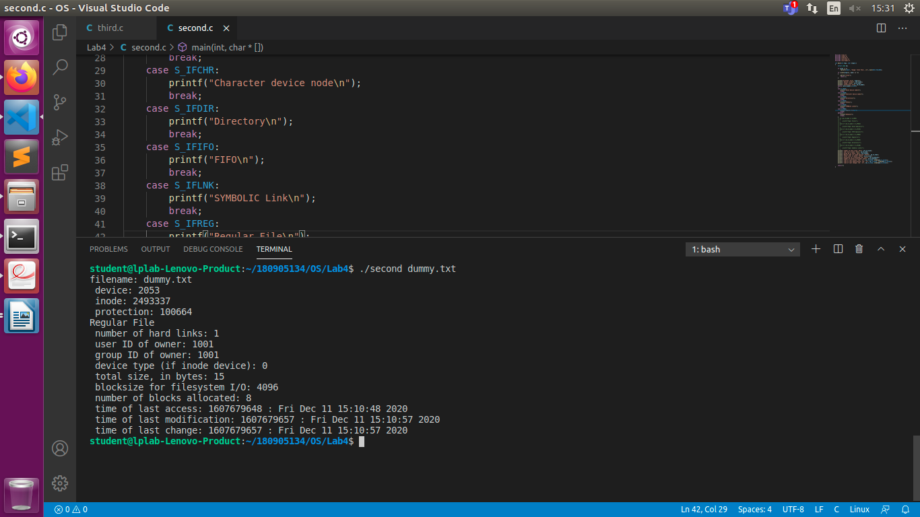

3.Hard Link

#include <stdio.h>
#include <stdlib.h>
#include <string.h>
#include <unistd.h>
#include <sys/types.h>
#include <sys/stat.h>
#include <time.h>

int main(int argc, char **argv)
{
struct stat sb;
if (argc == 1)
{
printf("No file name specified\n");
exit(0);
}
else if (argc == 3)
{
int status = link(argv[1], argv[2]);
if (status == 0)
{
printf("New hard link created at %s\n", argv[2]);
struct stat sb;
int status1 = stat(argv[2], &sb);
if (status1 == 0)
{
printf("Number of hard links %ld\n", sb.st_nlink);
}
else
{
printf("%m\n");
exit(1);
}
}
else
{
printf("%m\n");
exit(1);
}
status = unlink(argv[1]);
if (status == 0)
{
printf("Unlinked %s\n", argv[1]);
exit(0);
}
else
{
printf("%m\n");
exit(1);
}
}
else
{
printf("Incorrect number of arguments specified\n");
exit(1);
}
}

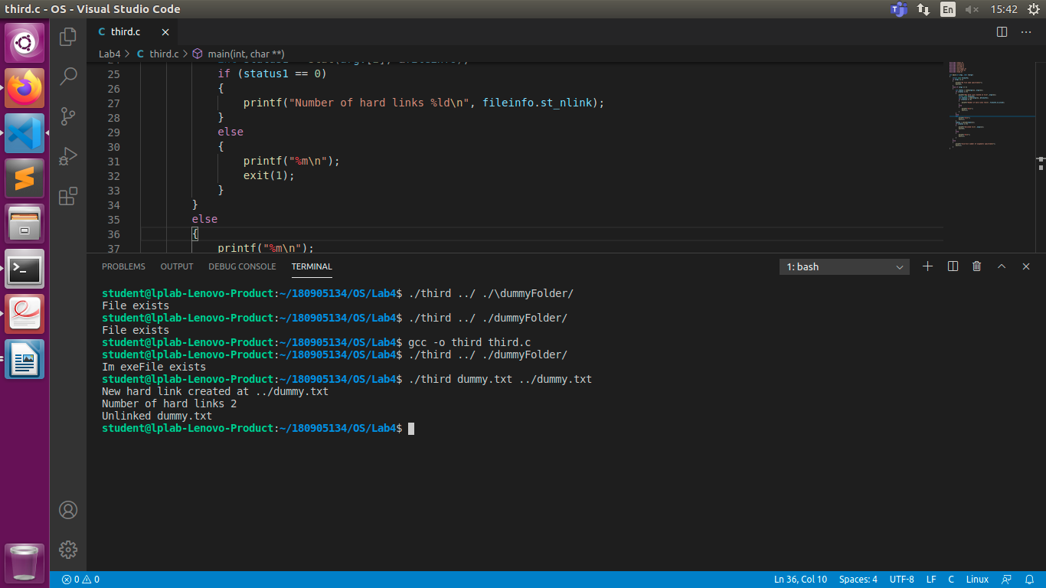
4. Soft Link
#include <stdio.h>
#include <stdlib.h>
#include <string.h>
#include <unistd.h>
#include <sys/types.h>
#include <sys/stat.h>
#include <time.h>

int main(int argc, char **argv)
{
struct stat fileinfo;
if (argc == 1)
{
printf("No file name specified\n");
exit(0);
}
else if (argc == 3)
{
int status = symlink(argv[1], argv[2]);
if (status == 0)
{
printf("New symlink created at %s\n", argv[2]);
}
else
{
printf("%m\n");
exit(1);
}
status = unlink(argv[2]);
if (status == 0)
{
printf("Unlinked %s\n", argv[2]);
exit(0);
}
else
{
printf("%m\n");
exit(1);
}
}
else
{
printf("Incorrect number of arguments specified\n");
exit(1);
}
}

